Hadoop Installation (Single Node Setup)

Step 1: Update Ubuntu
sudo apt update
sudo apt upgrade -y

Step 2: Install Java
Check available Java version:
java -version

Install OpenJDK:
sudo apt install openjdk-11-jdk -y

Verify installation:
java -version

Find Java path:
readlink -f $(which java)

Example output:
/usr/lib/jvm/java-11-openjdk-amd64/bin/java

JAVA_HOME will be:
/usr/lib/jvm/java-11-openjdk-amd64

Step 3: Create Hadoop User
sudo adduser hadoop

Give password and press Enter.
Add user to sudo group:
sudo usermod -aG sudo hadoop

Switch to Hadoop user:
su - hadoop

Step 4: Configure SSH
Install SSH:
sudo apt install openssh-server openssh-client -y

Generate SSH key:
ssh-keygen -t rsa -P ""

Press Enter for all prompts.
Enable passwordless SSH:
cat ~/.ssh/id_rsa.pub >> ~/.ssh/authorized_keys
chmod 600 ~/.ssh/authorized_keys

Test SSH:
ssh localhost

Type:
yes

Exit:
exit

Step 5: Download Hadoop
Move to home directory:
cd ~
Download Hadoop:
wget https://downloads.apache.org/hadoop/common/hadoop-3.4.1/hadoop-3.4.1.tar.gz

Extract Hadoop:
tar -xvzf hadoop-3.4.1.tar.gz

Rename folder:
mv hadoop-3.4.1 hadoop

Step 6: Configure Environment Variables
Open bashrc:
nano ~/.bashrc

Add these lines at the end:
export JAVA_HOME=/usr/lib/jvm/java-11-openjdk-amd64
export HADOOP_HOME=$HOME/hadoop
export HADOOP_INSTALL=$HADOOP_HOME
export HADOOP_MAPRED_HOME=$HADOOP_HOME
export HADOOP_COMMON_HOME=$HADOOP_HOME
export HADOOP_HDFS_HOME=$HADOOP_HOME
export YARN_HOME=$HADOOP_HOME
export HADOOP_COMMON_LIB_NATIVE_DIR=$HADOOP_HOME/lib/native
export PATH=$PATH:$HADOOP_HOME/sbin:$HADOOP_HOME/bin
export HADOOP_OPTS="-Djava.library.path=$HADOOP_HOME/lib/native"

Save and exit:
Ctrl + O
Enter
Ctrl + X

Apply changes:
source ~/.bashrc

Step 7: Configure hadoop-env.sh
Open file:
nano ~/hadoop/etc/hadoop/hadoop-env.sh

Find:
export JAVA_HOME=

Replace with:
export JAVA_HOME=/usr/lib/jvm/java-11-openjdk-amd64

Save and exit.

Step 8: Configure core-site.xml
Open file:
nano ~/hadoop/etc/hadoop/core-site.xml

Replace content between <configuration> tags:
<configuration>

<property>
<name>fs.defaultFS</name>
<value>hdfs://localhost:9000</value>
</property>

</configuration>

Save and exit.

Step 9: Configure hdfs-site.xml
Open file:
nano ~/hadoop/etc/hadoop/hdfs-site.xml

Replace content:
<configuration>

<property>
<name>dfs.replication</name>
<value>1</value>
</property>

<property>
<name>dfs.name.dir</name>
<value>file:///home/hadoop/hadoopdata/hdfs/namenode</value>
</property>

<property>
<name>dfs.data.dir</name>
<value>file:///home/hadoop/hadoopdata/hdfs/datanode</value>
</property>

</configuration>

Save and exit.

Step 10: Create HDFS Directories
mkdir -p ~/hadoopdata/hdfs/namenode
mkdir -p ~/hadoopdata/hdfs/datanode

Step 11: Configure mapred-site.xml
Copy template:
cp ~/hadoop/etc/hadoop/mapred-site.xml.template ~/hadoop/etc/hadoop/mapred-site.xml

Open file:
nano ~/hadoop/etc/hadoop/mapred-site.xml

Add:
<configuration>

<property>
<name>mapreduce.framework.name</name>
<value>yarn</value>
</property>

</configuration>

Save and exit.

Step 12: Configure yarn-site.xml
Open file:
nano ~/hadoop/etc/hadoop/yarn-site.xml

Add:
<configuration>

<property>
<name>yarn.nodemanager.aux-services</name>
<value>mapreduce_shuffle</value>
</property>

</configuration>

Save and exit.

Step 13: Format NameNode
hdfs namenode -format

Successful output:
Storage directory has been successfully formatted

Step 14: Start Hadoop Services
Start HDFS:
start-dfs.sh
Start YARN:
start-yarn.sh

Step 15: Verify Running Services
jps

Step 16: Check Hadoop Version
hadoop version

Step 17: Access Hadoop Web Interfaces
NameNode UI:
http://localhost:9870

ResourceManager UI:
http://localhost:8088

Step 18: Stop Hadoop
Stop YARN:
stop-yarn.sh

Stop HDFS:
stop-dfs.sh

Quick Verification Commands

java -version

hadoop version
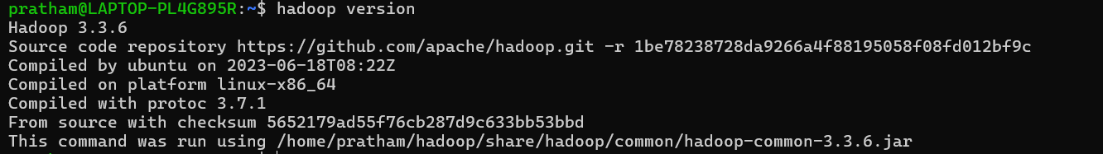

jps


hdfs dfsadmin -report
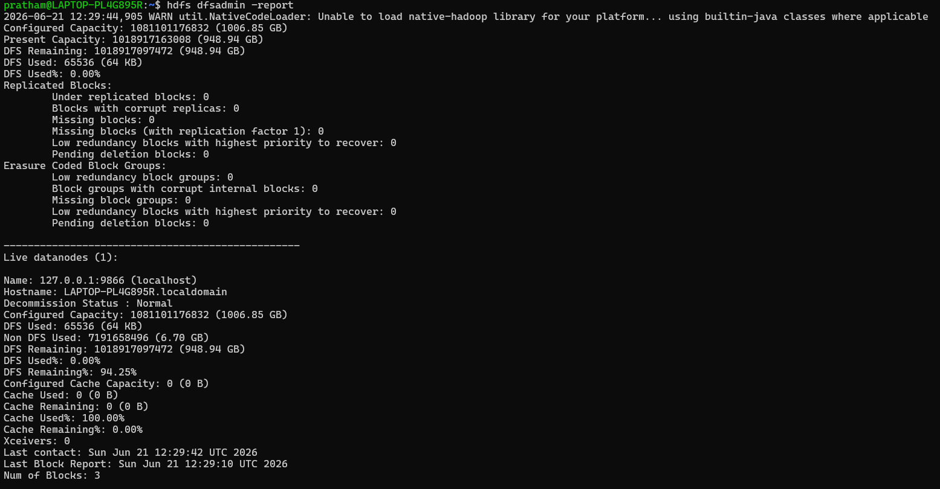

hdfs dfs -ls /

